SALES PERFORMANCE
DASHBOARD REPORT
Project Report Submitted By
Name: Kaviya D

Introduction
This project presents an interactive Sales Performance Dashboard developed in Microsoft Power BI. The dashboard converts sales data into visual summaries that can be explored through year, category and region filters, together with detailed pages for category, month, region, employee and product-level analysis.
The dashboard is designed to make a large sales dataset easier to understand at a glance. Instead of relying only on a table, it combines KPI cards, column and line charts, a doughnut chart, a horizontal bar chart and a detailed table so that overall performance and individual records can be viewed together.

Objectives
- Analyze overall sales, cost, profit and quantity using Power BI.
- Create an interactive dashboard rather than a static report.
- Compare sales performance across different product categories.
- Track the movement of total sales across months.
- Compare the contribution of the five regions to total sales.
- Examine profit performance across employees.
- Provide detailed product-level information for further analysis.

Dataset Description
The dashboard uses sales records that are summarized by product, category, region, employee and month. The detailed table visible in the report contains ProductName, Total Quantity, Total Profit, Total Sales and Total Cost. The dashboard also provides Year, Category and Region as interactive filters.
Field / Dimension | Meaning | Use in Dashboard
ProductName | Product identifier/name | Product-level table and detailed analysis
Total Quantity | Quantity sold | KPI and product comparison
Total Profit | Profit generated | KPI and employee analysis
Total Sales | Sales value | Main KPI and category/month/region visuals
Total Cost | Cost associated with sales | KPI and product-level comparison
Category | Product category | Category filter and sales comparison
Region | Sales region | Region filter and sales contribution
EmployeeName | Employee identifier/name | Profit performance comparison
MonthName | Month label | Monthly sales trend

Data Preparation
- The sales data was brought into Power BI Desktop and organized for dashboard analysis.
- Sales, cost, profit and quantity were used as numerical fields for aggregation.
- Category, Region, EmployeeName, ProductName and MonthName were used as analytical dimensions.
- Year, Category and Region were placed as slicers so the dashboard can be filtered interactively.
- The report was arranged into a main summary page and separate drill-through/detail pages for focused analysis.

Measures and Calculations Used
The dashboard is built around aggregated measures that dynamically display the values shown in the KPI cards and detailed visuals. The visible measures include Total Cost, Total Profit, Total Sales and Total Quantity.
Measure | Purpose in the Dashboard
Total Cost | Shows the overall cost represented by the current dashboard/filter context.
Total Profit | Shows the overall profit and supports employee-level profit comparison.
Total Sales | Shows overall sales and is used in category, month and region visuals.
Total Quantity | Shows the overall quantity sold and supports product-level analysis.

Dashboard Overview
The main dashboard brings the sales analysis together on one page. Four KPI cards show Total Cost, Total Profit, Total Sales and Total Quantity. The lower visuals examine sales by category, sales by month, sales by region, profit by employee and product-level values. The Year, Category and Region slicers allow the user to narrow the analysis.
The report also uses a Back to report button on the detailed pages. This supports easy navigation from a focused analysis page back to the main dashboard.

Main Dashboard Overview
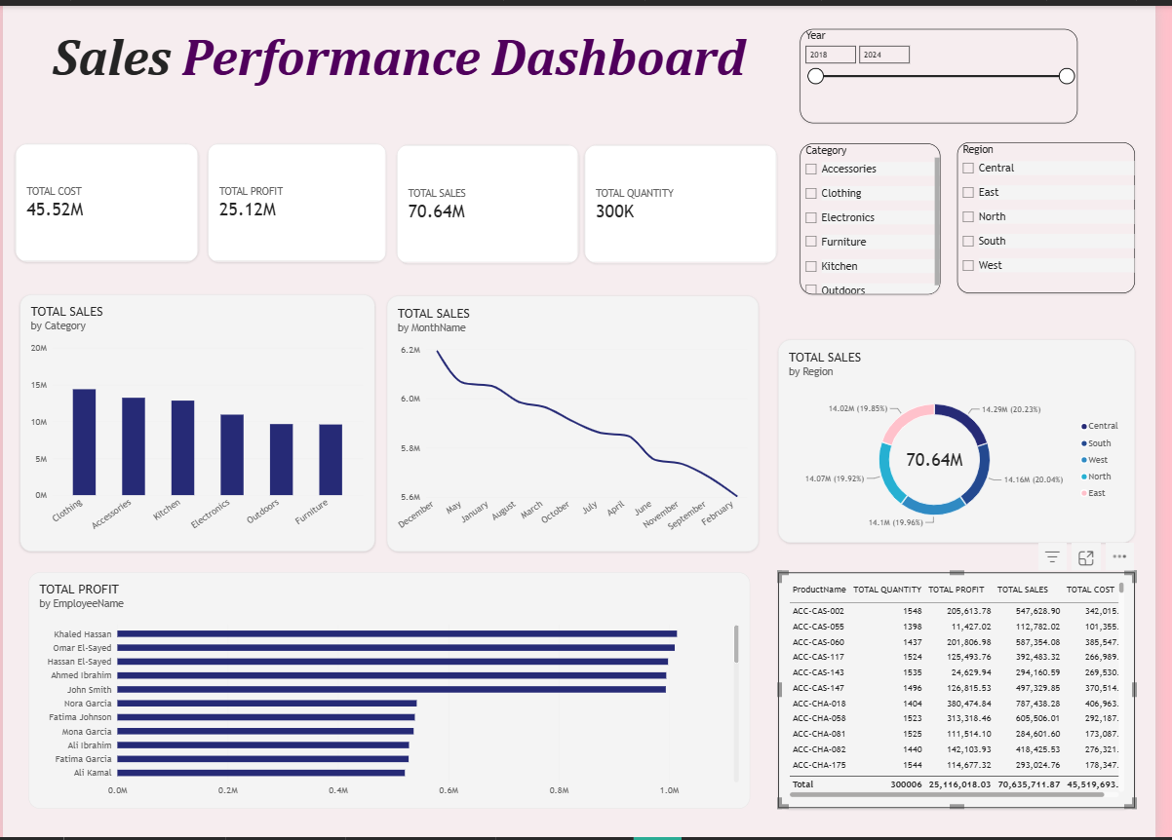
The main dashboard provides a consolidated view of sales performance. The KPI cards display Total Cost of 45.52M, Total Profit of 25.12M, Total Sales of 70.64M and Total Quantity of 300K. These indicators give an immediate view of the overall scale of the data.

Key Observations
- Total Sales is 70.64M, while Total Profit is 25.12M, showing the overall sales and profit position displayed in the report.
- The category chart shows Clothing as the highest-sales category among the displayed categories.
- The monthly visual presents sales values across the twelve month names used in the dashboard.
- The region doughnut chart shows a relatively balanced distribution of sales across Central, South, West, North and East.
- The employee visual compares Total Profit across employees, while the table provides product-level details.
- Year, Category and Region slicers make the dashboard interactive and allow the displayed values to change with user selections.

Total Sales by Category
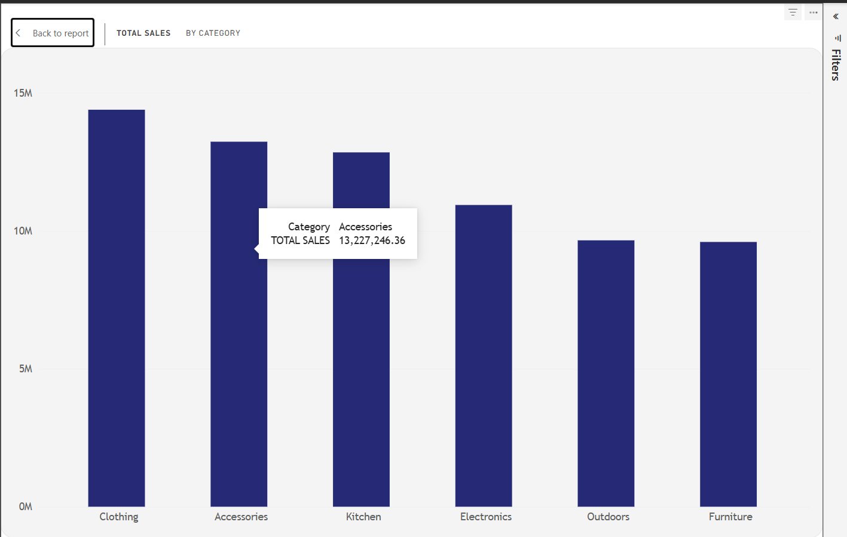
The column chart compares Total Sales across six product categories: Clothing, Accessories, Kitchen, Electronics, Outdoors and Furniture. The height of each column makes the relative sales contribution of each category easy to compare.

Key Findings
- Clothing records the highest Total Sales among the displayed categories.
- Accessories and Kitchen follow Clothing, with both showing strong sales contributions.
- Electronics records lower sales than the three leading categories.
- Outdoors and Furniture are the lowest two categories in the displayed comparison.
- The tooltip shown for Accessories gives Total Sales of 13,227,246.36, providing a precise value when the visual is explored.
The Back to report button at the top of the page allows the user to return to the main dashboard after completing the category analysis.

Total Sales by MonthName
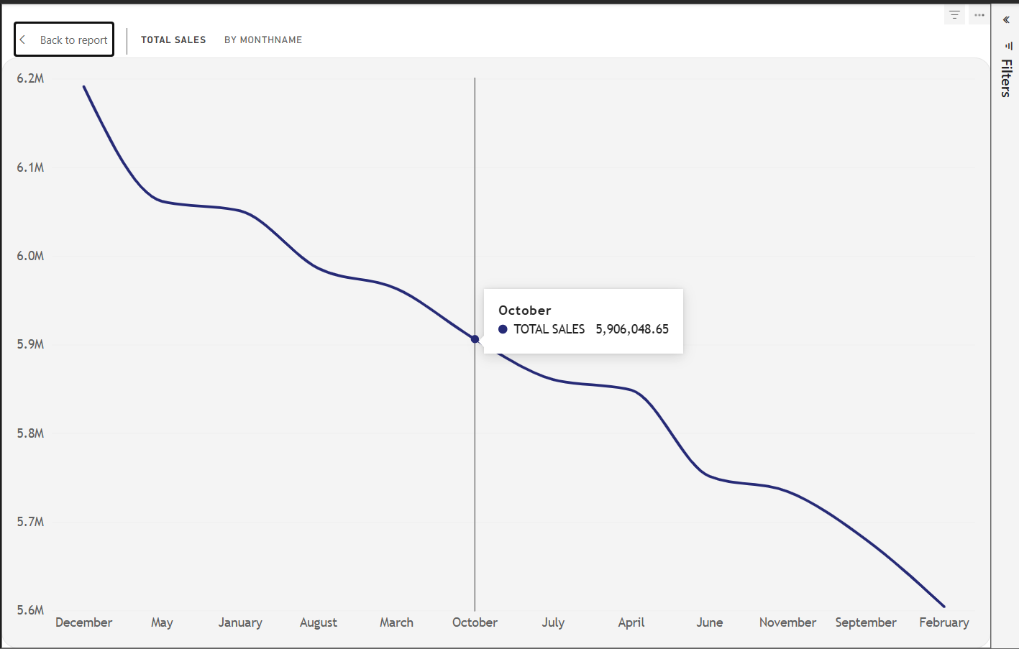
The line chart presents Total Sales across the month names in the dashboard. It provides a visual way to compare sales values from one month to another and identify months with comparatively higher or lower sales.

Key Findings
- December appears at the highest point in the displayed monthly comparison, at approximately 6.2M.
- Sales then move downward through several months, showing variation across the reporting period.
- The highlighted October value is 5,906,048.65.
- February appears at the lowest point in the displayed sequence, at approximately 5.6M.
- The visual is useful for identifying monthly changes and selecting periods that may need closer investigation.
The Back to report button provides simple navigation from the month-level analysis back to the main dashboard.

Total Sales by Region
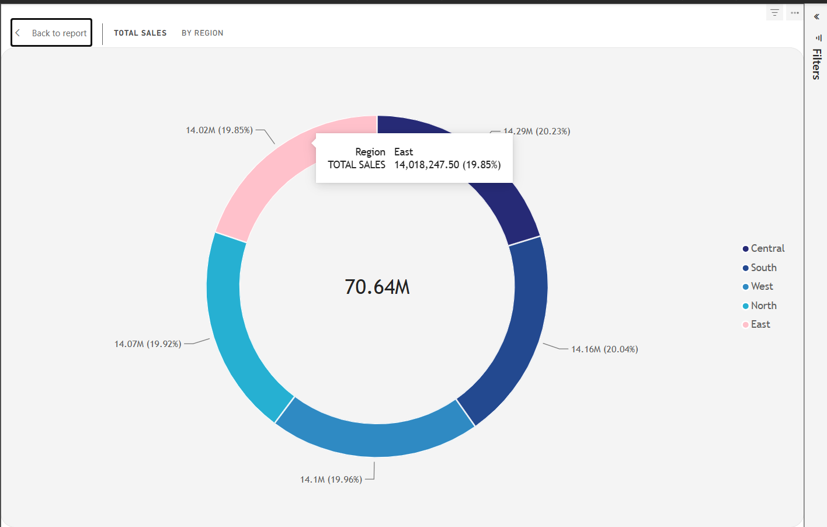
The doughnut chart shows how the overall Total Sales of 70.64M is distributed across five regions: Central, South, West, North and East. The labels display both the sales value and percentage contribution for each region.

Key Findings
- Central contributes approximately 14.29M, representing 20.23% of Total Sales.
- South contributes approximately 14.16M, representing 20.04% of Total Sales.
- West contributes approximately 14.10M, representing 19.96% of Total Sales.
- North contributes approximately 14.07M, representing 19.92% of Total Sales.
- East contributes approximately 14.02M, representing 19.85% of Total Sales.
- The percentages are close to one another, indicating that sales are distributed fairly evenly across the five displayed regions.
The Back to report button allows the user to return to the summary dashboard.

Total Profit by EmployeeName
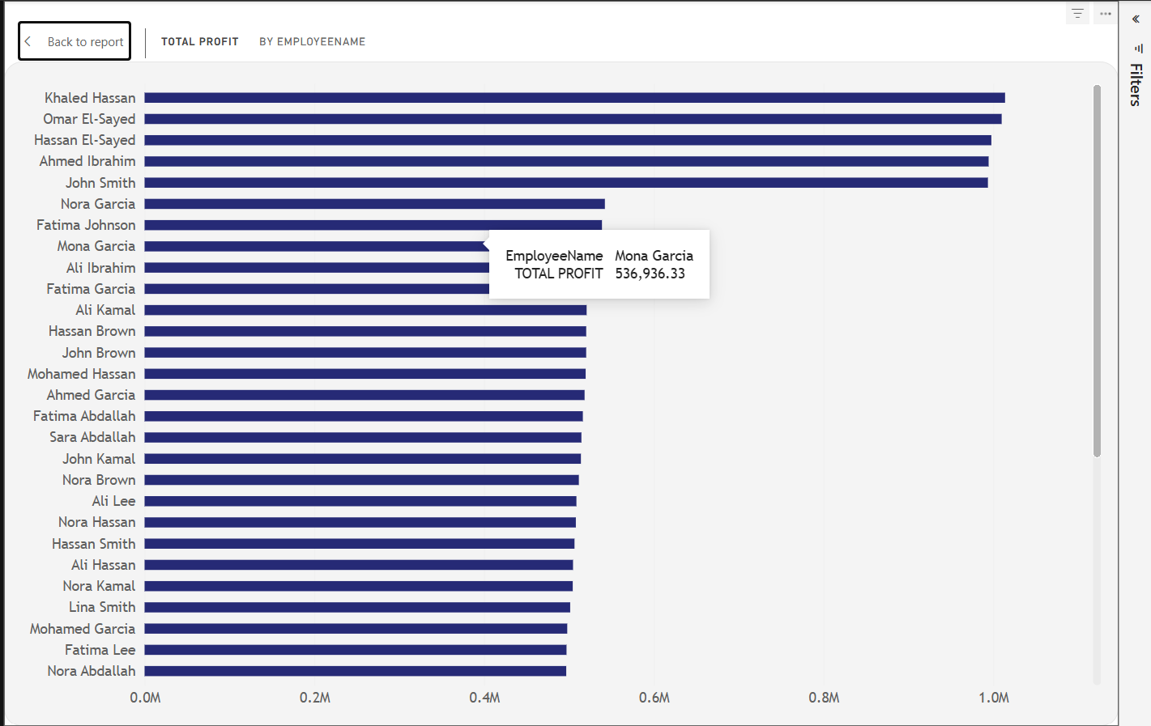
The horizontal bar chart compares Total Profit across employees. The visual contains a larger number of employee names, so the horizontal layout makes it easier to read names and compare their profit values.

Key Findings
- Khaled Hassan, Omar El-Sayed, Hassan El-Sayed, Ahmed Ibrahim and John Smith are among the highest values visible in the chart.
- The chart shows a clear difference between the leading employees and several employees with lower profit values.
- The highlighted tooltip for Mona Garcia shows Total Profit of 536,936.33.
- The visual can be used to compare employee-level profit contribution and identify differences in performance.
- The scroll bar on the visual allows the user to examine additional employee records beyond the names visible in the initial view.
The Back to report button provides navigation back to the main dashboard.

Product-Level Sales Details
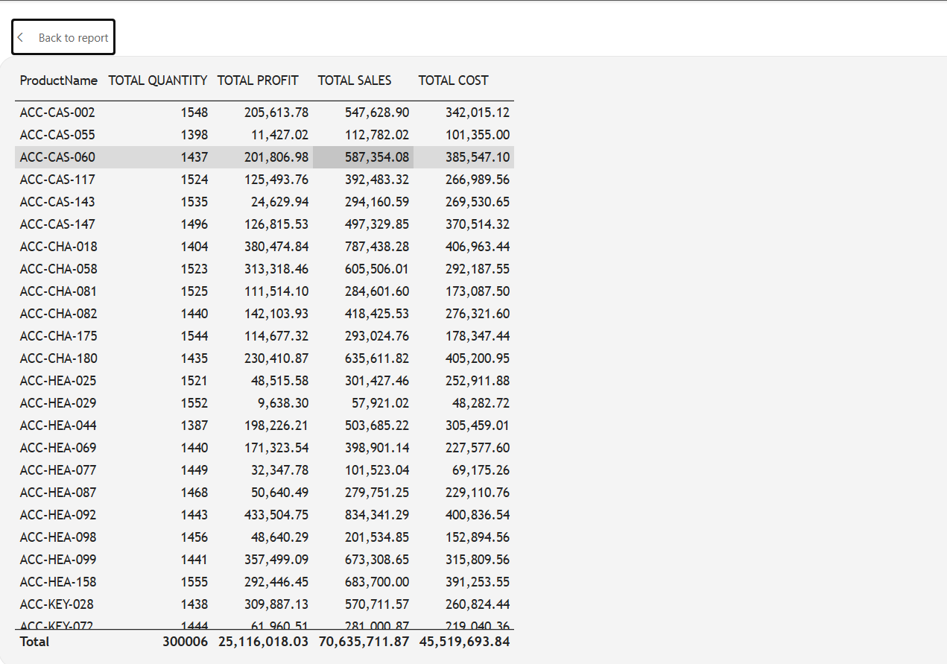
The detailed table provides a record-level view of product performance. It contains ProductName, Total Quantity, Total Profit, Total Sales and Total Cost. This visual complements the summary charts by allowing the user to inspect individual products and their financial contribution.

Key Findings
- The table contains detailed product identifiers such as ACC-CAS-002, ACC-CAS-055 and ACC-CAS-060.
- The visible totals at the bottom show Total Quantity of 300006, Total Profit of 25,116,018.03, Total Sales of 70,635,711.87 and Total Cost of 45,519,693.84.
- Product-level values can be compared across quantity, profit, sales and cost at the same time.
- The table supports more detailed investigation when a summary chart does not provide enough product-level information.
- The selected row in the screenshot demonstrates Power BI's interactive highlighting/selection behaviour.
The Back to report button at the top left supports navigation back to the main report page.

Key Findings
Area | Finding
Overall scale | The dashboard displays Total Sales of 70.64M, Total Profit of 25.12M, Total Cost of 45.52M and Total Quantity of 300K.
Category performance | Clothing has the highest displayed Total Sales, while Furniture and Outdoors are at the lower end of the category comparison.
Monthly sales | The monthly visual ranges from approximately 5.6M to 6.2M, with December at the highest displayed point.
Regional contribution | The five regions contribute similar shares, each close to 20% of the displayed Total Sales.
Employee profit | The employee chart shows differences in Total Profit, with several employees near 1.0M and others at lower levels.
Product detail | The product table allows simultaneous comparison of quantity, profit, sales and cost for individual products.
Interactivity | Year, Category and Region slicers support filtering, while Back to report buttons support navigation between the summary and detail pages.

Conclusion
The Sales Performance Dashboard successfully converts detailed sales records into an interactive Power BI report. The combination of KPI cards, category analysis, monthly sales tracking, regional contribution, employee profit comparison and product-level details provides a clear view of overall performance.
The dashboard shows strong variation across product categories and employees, while the regional distribution is relatively balanced. The slicers and navigation buttons improve usability by allowing the viewer to filter the report and move between summary and detailed views. Overall, the report provides a practical visual approach for understanding sales, cost, profit and quantity performance.

